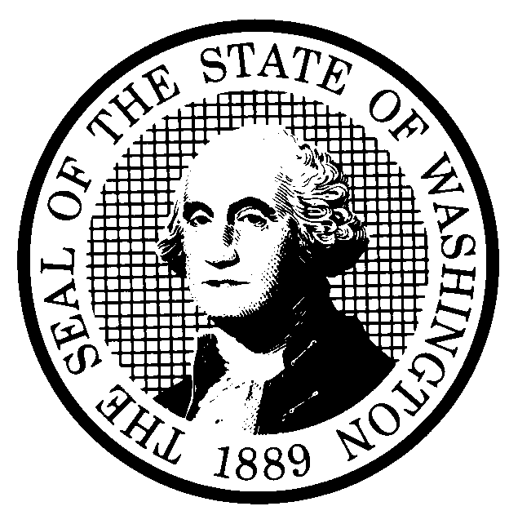  PREPROPOSAL STATEMENT  OF INQUIRY |  |  |  | CODE REVISER USE ONLY
CR-101 (October 2017)  (Implements RCW 34.05.310)  Do NOT use for expedited rule making |  |  |  | CODE REVISER USE ONLY
Agency: Washington State Noxious Weed Control Board
Subject of possible rule making: 16-750
Statutes authorizing the agency to adopt rules on this subject: RCW 17.10.010, RCW 17.10.070, RCW 17.10.080, RCW 17.10.350
Reasons why rules on this subject may be needed and what they might accomplish:
The State Noxious Weed Control Board is charged with updating the state noxious weed list on an annual basis to ensure it accurately reflects the noxious weed control priorities and noxious weed distribution as well as updating its bylaws that are codified in WAC 16-750. The State Noxious Weed Control Board may also consider other updates to WAC 16.750.

Identify other federal and state agencies that regulate this subject and the process coordinating the rule with these agencies:
No other state agency regulates this subject. Federal agencies are subject to federal noxious weed laws that require them to coordinate with state regulations. Federal agencies in Washington are invited to participate in all stages of noxious weed rule making.

Process for developing new rule (check all that apply):
☐ Negotiated rule making
☐ Pilot rule making
☐ Agency study
☒ Other (describe)
The WSNWCB annually solicits proposed changes to the noxious weed list from county weed boards, weed districts, state agencies, federal agencies, interest groups, and the general public. The Noxious Weed Committee of the Board (which includes representation from the Washington Native Plant Society, county weed boards, the nursery industry and several scientific advisors) meets at least twice to review and research these suggestions. A public hearing is scheduled, and a press release and information regarding the proposed changes are widely distributed to newspapers,

Interested parties can participate in the decision to adopt the new rule and formulation of the proposed rule before publication by contacting:
 |  | (If necessary)
Name: Mary Fee |  | Name:
Address: | 1111 Washington St SE | Address:
Phone: 360-561-4428 |  | Phone:
Fax: 360-902-2094 |  | Fax:
TTY: |  | TTY:
  (800) 833-6388
Email: mfee@agr.wa.gov |  | Email:
Web site: www.nwcb.wa.gov |  | Web site:
Other: |  | Other:
Additional comments:
Date: 07/02/2025  Name: Mary Fee  Title: WSNWCB Executive Secretary |  | Signature:  