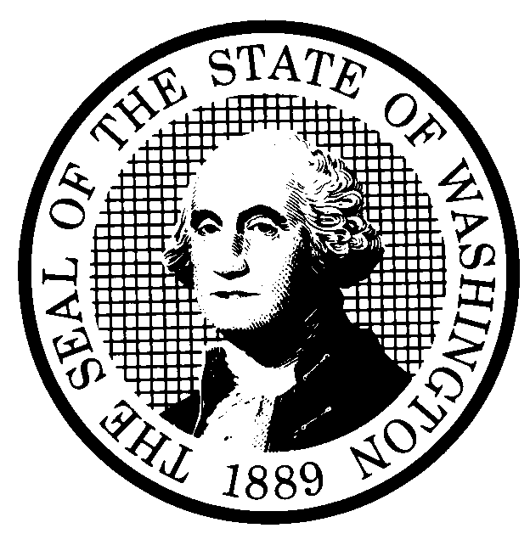  PROPOSED RULE MAKING |  |  |  |  |  |  | CODE REVISER USE ONLY
CR-102 (June 2024)
(Implements RCW 34.05.320)
Do NOT use for expedited rule making
Agency: Washington State Noxious Weed Control Board
☒ Original Notice
☐ Supplemental Notice to WSR
☐ Continuance of WSR
☒ Preproposal Statement of Inquiry was filed as WSR 25-15-007 ; or
☐ Expedited Rule Making--Proposed notice was filed as WSR ; or
☐ Proposal is exempt under RCW 34.05.310(4) or 34.05.330(1); or
☐ Proposal is exempt under RCW .
Title of rule and other identifying information: (describe subject) Chapter 16-750 WAC, State noxious weed list and schedule of monetary penalties. The Washington State Noxious Weed Control Board is proposing to amend pronouns and the state noxious weed list for 2025,.
Hearing location(s):
Date: | Time: | Location: (be specific) | Comment:
November 4th, 2025 | 1:00 pm | Wenatchee Valley Chamber of Commerce  137 N Wenatchee Ave Ste 101, Wenatchee, WA 98801  Also virtually via Zoom  https://us02web.zoom.us/j/7061977054?omn=89518665665 | This Hearing will be held both in person and virtually through Zoom.

Date of intended adoption: November 5th (Note: This is NOT the effective date)
Submit written comments to: |  |  |  |  | Assistance for persons with disabilities:
Name Mary Fee |  |  |  |  | Contact
Address |  |  |  |  | Phone
Email |  |  |  |  | Fax
Fax |  |  |  |  | TTY
Other |  |  |  |  | Email
Beginning (date and time) |  |  |  |  | Other
By (date and time) |  |  |  |  | By (date)
Purpose of the proposal and its anticipated effects, including any changes in existing rules:
Reasons supporting proposal:
Statutory authority for adoption:
Statute being implemented:
Is rule necessary because of a:
Federal Law? |  |  |  |  |  |  |  | ☐ Yes | ☐ No
Federal Court Decision? |  |  |  |  |  |  |  | ☐ Yes | ☐ No
State Court Decision? |  |  |  |  |  |  |  | ☐ Yes | ☐ No
If yes, CITATION:
Agency comments or recommendations, if any, as to statutory language, implementation, enforcement, and fiscal matters:
Name of proponent: (person or organization)
Type of proponent: ☐ Private. ☐ Public. ☐ Governmental.
Name of agency personnel responsible for:
Name |  |  | Office Location |  |  |  |  | Phone
Drafting
Implementation
Enforcement
Is a school district fiscal impact statement required under RCW 28A.305.135? |  |  |  |  |  |  |  | ☐ Yes | ☐ No
If yes, insert statement here:

The public may obtain a copy of the school district fiscal impact statement by contacting:
Name
Address
Phone
Fax
TTY
Email
Other
Is a cost-benefit analysis required under RCW 34.05.328?
☐ Yes: A preliminary cost-benefit analysis may be obtained by contacting:
Name
Address
Phone
Fax
TTY
Email
Other
☐ No: Please explain:
Regulatory Fairness Act and Small Business Economic Impact Statement
Note: The Governor's Office for Regulatory Innovation and Assistance (ORIA) provides support in completing this part.
(1) Identification of exemptions:
This rule proposal, or portions of the proposal, may be exempt from requirements of the Regulatory Fairness Act (see chapter 19.85 RCW). For additional information on exemptions, consult the exemption guide published by ORIA. Please check the box for any applicable exemption(s):
☐ This rule proposal, or portions of the proposal, is exempt under RCW 19.85.061 because this rule making is being adopted solely to conform and/or comply with federal statute or regulations. Please cite the specific federal statute or regulation this rule is being adopted to conform or comply with, and describe the consequences to the state if the rule is not adopted.
Citation and description:
☐ This rule proposal, or portions of the proposal, is exempt because the agency has completed the pilot rule process defined by RCW 34.05.313 before filing the notice of this proposed rule.
☐ This rule proposal, or portions of the proposal, is exempt under the provisions of RCW 15.65.570(2) because it was adopted by a referendum.
☐ This rule proposal, or portions of the proposal, is exempt under RCW 19.85.025(3). Check all that apply:
☐ | RCW 34.05.310 (4)(b) |  |  |  | ☐ | RCW 34.05.310 (4)(e)
 | (Internal government operations) |  |  |  |  | (Dictated by statute)
☐ | RCW 34.05.310 (4)(c) |  |  |  | ☐ | RCW 34.05.310 (4)(f)
 | (Incorporation by reference) |  |  |  |  | (Set or adjust fees)
☐ | RCW 34.05.310 (4)(d) |  |  |  | ☐ | RCW 34.05.310 (4)(g)
 | (Correct or clarify language) |  |  |  |  | ((i) Relating to agency hearings; or (ii) process
requirements for applying to an agency for a license
or permit)
☐ This rule proposal, or portions of the proposal, is exempt under RCW 19.85.025(4). (Does not affect small businesses).
☐ This rule proposal, or portions of the proposal, is exempt under RCW .
Explanation of how the above exemption(s) applies to the proposed rule:
(2) Scope of exemptions: Check one.
☐ The rule proposal: Is fully exempt. (Skip section 3.) Exemptions identified above apply to all portions of the rule proposal.
☐ The rule proposal: Is partially exempt. (Complete section 3.) The exemptions identified above apply to portions of the rule proposal, but less than the entire rule proposal. Provide details here (consider using this template from ORIA):
☐ The rule proposal: Is not exempt. (Complete section 3.) No exemptions were identified above.
(3) Small business economic impact statement: Complete this section if any portion is not exempt.
If any portion of the proposed rule is not exempt, does it impose more-than-minor costs (as defined by RCW 19.85.020(2)) on businesses?
☐ No Briefly summarize the agency’s minor cost analysis and how the agency determined the proposed rule did not impose more-than-minor costs.
☐ Yes Calculations show the rule proposal likely imposes more-than-minor cost to businesses and a small business economic impact statement is required. Insert the required small business economic impact statement here:

The public may obtain a copy of the small business economic impact statement or the detailed cost calculations by contacting:
Name
Address
Phone
Fax
TTY
Email
Other
Date:  Name:  Title: |  |  |  | Signature:  Place signature here

