**WRITTEN FINDINGS OF THE**

**WASHINGTON STATE NOXIOUS WEED CONTROL BOARD**

**Draft: August 27, 2012**

## Scientific name: *Dipsacus* *fullonum* L.

Synonyms: *Dipsacus sylvestris* Huds., Dipsacus fullonum L. ssp. sylvestris (Huds.) Clapham

Common name: Wild teasel, common teasel, Fuller’s teasel

Family: Dipsacaceae

Legal Status: proposed for Class C noxious weed

**Description and Variation:**

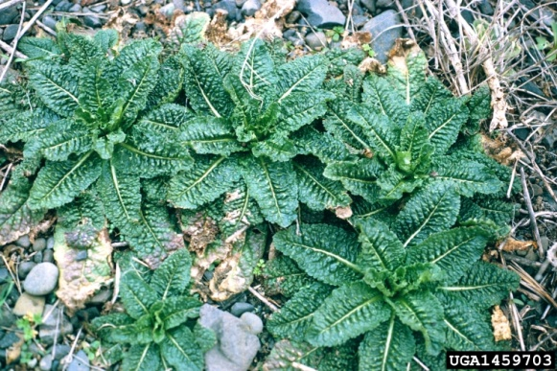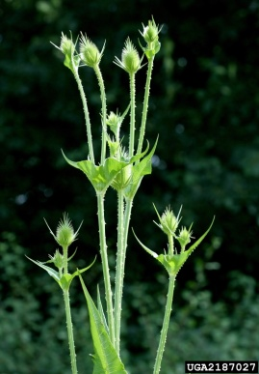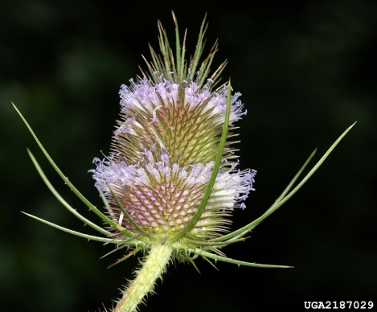

Figure 1. *Dipsacus fullonum* rosettes (Steve Dewey, Utah State University, Bugwood.org); developing flower stems with opposite leaves (David Cappaert, Michigan State University, Bugwood.org); *Dipsacus fullonum* in flower (David Cappaert, Michigan State University, Bugwood.org).

Overall Habit:

*Dipsacus fullonum* is a taprooted, monocarpic plant that grows as a biennial or short-lived perennial that dies after it flowers (Hitchcock et al. 1959, Donaldson and Rafferty n.d.).

Roots/Rhizomes:

Plants develop a stout, fleshy taproot in the rosette stage that can be more than 2 feet long and 1 inch in diameter at the crown (DiTomaso and Healy 2007, Donaldson and Rafferty n.d.).

Stems:

The second year flower stems grow 0.5-2 meters tall (Hitchcock et al. 1959). They are striate-angled and increasingly prickly going upward (Hitchcock et al. 1959). Stems are pithy or hollow and have opposite branching (Werner 1975a).

Leaves:

Basal leaves are oblanceolate with crenate margins and typically die early in the second season (Hitchcock et al. 1959). The basal leaves have rigid spines on the underside of the midrib and smaller spines on papilate bases on the upper leaf surface (Werner 1975a). The stem leaves are opposite and more or less prickly, especially on the lower side of the leaf midrib (Hitchcock et al. 1959). Stem leaves are lanceolate, up to 30 cm long, with leaf margins becoming entire upward (Hitchcock et al. 1959). Stem leaves are commonly connate into a water-collecting cup at the base (Hitchcock et al. 1959).

Flowers:

Dense flowerheads occur individually on long, leafless peduncles at the apex of the main stem and terminally on opposite side branches (Chessman 1998). They are upright, ovoid or subcylindric and 3-10 cm long. Involucral bracts are linear, more or less prickly, curved upward and unequal in length with the longer ones surpassing the flowerheads (Hitchcock et al. 1959). Bracts on the receptacle, just below each flower, end in a conspicuous, stout, straight awn that is longer than the flower (Hitchcock et al. 1959, DiTomaso and Healy 2007). The flower calyx is cup-shaped, 4-angled, silky and 1 mm long (Hitchcock et al. 1959). The flower corolla is slender, pubescent, 10-15 mm long. The corolla tube is whitish and has 4 short (1 mm) lobes that are generally pale purple or dark pink (Hitchcock et al. 1959, Werner 1975a). Flowers have 4 stamens (Hitchcock et al. 1959). Flowers around the middle of the flowerhead mature first, and two rings of flowers mature sequentially from the middle ring, one moving upward and the other downward (DiTomaso and Healy 2007). Flowerheads on the main stem flower first with flowerheads on secondary and lower orders of branching blooming later (Chuko and Hanyu 1990).

Fruits and Seeds:

Fruits are dry, indehiscent achenes and about 3-6 (-8) mm long and typically have 8 pale ribs (Hitchcock et al. 1959, DiTomaso and Healy 2007).

**Look a-likes**

Two other similar looking species of *Dipsacus* have been introduced into North America, *D. laciniatus* (cutleaf teasel) and *D. sativus* (cultivated teasel). *D. laciniatus* differs from *D. fullonum* by its irregularly-cut pinnatifid leaves, white flowers and shorter involucral bracts which do not surpass the flowerhead (Werner 1975a). *D. sativus* mainly differs from *D. fullonum* by the awns of the bracts on the receptacle being shorter, stiffer and recurved into a strong hook shape; also, flowers are pinkish-lilac and the involucral bracts are like that of *D. laciniatus* (Werner 1975a).

**Habitat:**

*Dipsacus* *fullonum* escapes cultivation and can be found in and around garden areas, spreading along creeks and pond edges, pastures, seeps, sedge meadows, roadsides, dumps, abandoned fields and other disturbed sites (Donaldson and Rafferty n.d., Ohio Dept. of Natural Resources 2001). *D.* *fullonum* is also growing into agricultural areas, fallow fields, pasture lands and hay meadows (J. Hinton Skagit County Noxious Weed Control Board pers. comm. 2012, San Juan County Noxious Weed Control Board, 2012). Plants can be reduced in size where cattle graze, and this may be due to the trampling of rosettes (Werner 1975a). It can also be found around cemeteries where the dried seed heads were used in decorative flower arrangements (Donaldson and Rafferty n.d.).

*Dipsacus fullonum* prefers open, sunny habitats and can survive in a range of wet to dry conditions (Donaldson and Rafferty n.d.). *D. fullonum* grows best in poorly drained soils and areas prone to flooding (Rector et al. 2006). Soils include sandy soils when abundant moisture is available to heavy clay soils in poorly drained areas such as ditches or low spots (Werner 1975a). It can also survive in saline conditions (Ohio Dept. of Natural Resources 2001), more so than other roadside plants, thus giving it an advantage along roadsides that are salted during the winter (Beaton and Dudley, 2004 in Rector et al. 2006).

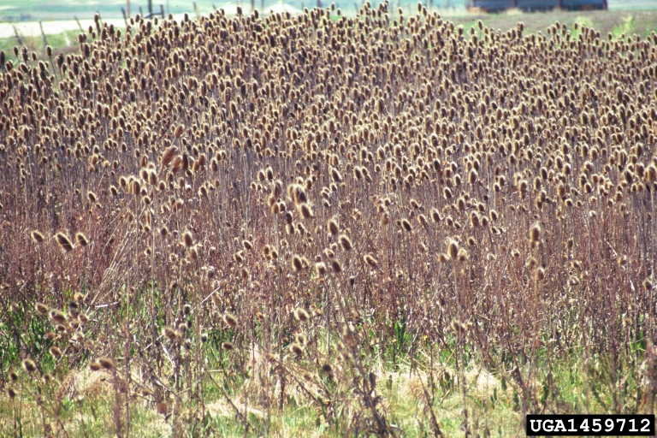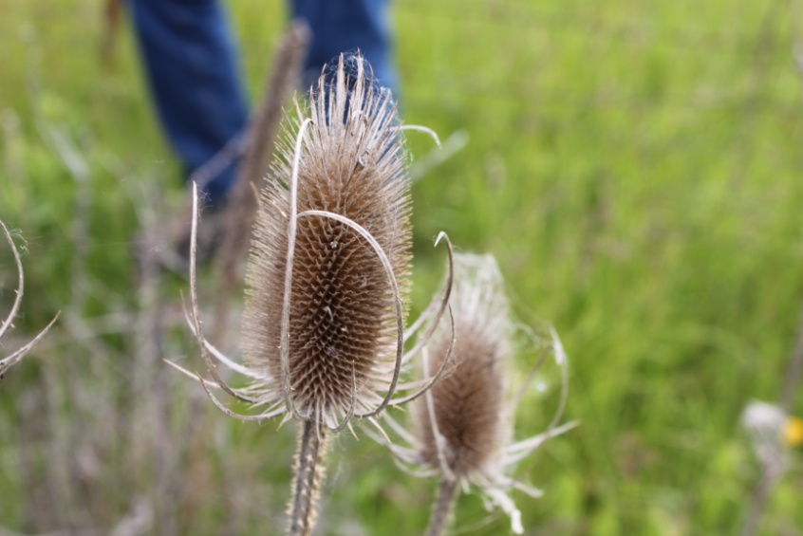

Figure 2. Left: *Dipsacus* *fullonum* roadside infestation. Image: Steve Dewey, Utah State University, Bugwood.org. Right: *D. fullonum* flowerheads gone to seed. Image: WSNWCB.

Geographic Distribution:

*Dipsacus fullonum* is naturalized in a number of places including Africa, Australia, New Zealand, North America and South America (USDA ARS 2011).

Native Distribution:

*Dipsacus fullonum* is native to Algeria, Morocco, Tunisia, Lebanon, Syria, Turkey, Ireland, United Kingdom, France, Portugal, Spain, Austria, Belgium, Czech Republic, Slovakia, Germany, Hungary, Netherlands, Poland, Switzerland, Moldova, Ukraine, Albania, Bulgaria, Former Yugoslavia, Greece, Italy and Romania (USDA ARS 2011).

Distribution in North America:

*Dipsacus fullonum* is thought to have been introduced to North American as early as the 1700s as a horticultural plant and used in wool fleecing (Donaldson and Rafferty n.d.). Edgin and Glass (2007) note that teasel has spread rapidly in the last 30-40 years and that this expansion has been aided by construction of the interstate highway system.

The USDA’s Plants database (USDA NRCS 2011) documents *Dipsacus fullonum* in Canada and the United States. In Canada, it is documented in British Columbia, Ontario, Quebec and Manitoba. In the United States it is documented in all states except Alaska, Hawaii, Louisiana, Georgia, South Carolina, Florida and Maine. EDDMapS (2011) does document it in Maine but not North Dakota, though USDA Plants Database (2011) notes it is present there.

*Dipsacus fullonum* is listed in Colorado as a Class B noxious weed, in Iowa as a secondary noxious weed, in Missouri as a noxious weed, and in New Mexico as a Class B noxious weed.

History and Distribution in Washington:

The University of Washington Burke Herbarium (2011) documents *Dipsacus fullonum* in Jefferson, Mason, Pacific, Wahkiakum, Cowlitz, Clark, Lewis, King, Snohomish, Skagit, Island, San Juan, Kittitas, Yakima, Klickitat, Douglas, Pend Oreille, Stevens, Lincoln, Adams, Whitman, Columbia and Walla Walla counties(see map). The earliest herbarium record in Washington is from Clark County, collected in 1923 (Otis 1258).

An increase in the spread of *Dipsacus fullonum* has been observed in the parts of western Washington, especially in agricultural lands of Skagit and Island counties (J. Hinton Skagit County Noxious Weed Control Board personal communication 2012, M. Shelly, Western WA Agricultural Association pers. comm. 2012, L. Engle Island County Farm Bureau 2012, B. Rogers Skagit County Noxious Weed Control Board pers. comm. 2012)

An informal survey of county noxious weed board coordinators in 2012 found, with a response of 24 out of 39 counties, that all counties had various amount of *D. fullonum* and that some noted it appeared to be increasing its range. Counties with *D. fullonum* that are not included in the University of Washington Burke Herbarium records but were noted to have it from the survey include Clallam, Grays Harbor, Skamania, Whatcom, Okanogan, Spokane, Franklin and Asotin counties.

San Juan County Noxious Weed Control Board lists *Dipsacus fullonum* on its list of ‘Unregulated Weeds of Special Concern’ and it has been a high priority for removal along county right-of-ways and on private property for the past several years (San Juan County Noxious Weed Control Board pers. comm. 2012).

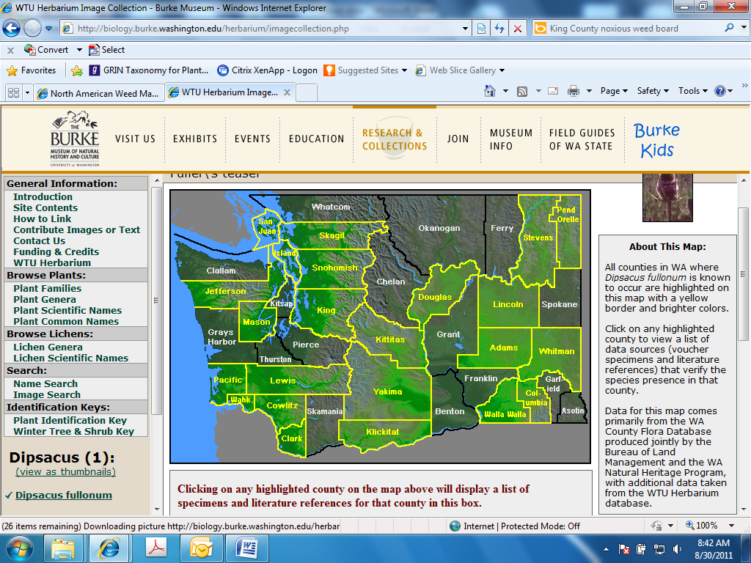

Figure 3. Map of highlighted counties indicating where *Dipsacus fullonum* is documented by herbarium records to occur in Washington State (WTU image database).

**Biology:**

Growth and Development:

*D. fullonum* seeds can germinate from spring to late summer (Werner 1975a). Plants grow a basal rosette at least one year and develop a stout taproot. Plants may remain as a basal rosette more than one year depending on the size of the rosette at the end of the growing season (Werner 1975b). A rosette will form a flower stalk after attaining a critical size, generally greater than 30 cm in diameter (Werner 1975b). The flower stalk usually begins to grow in May and reaches full size by early July (Werner 1975a).

*Dipsacus fullonum* blooms from July to September (Hitchcock et al. 1959). Flowers are primarily pollinated by bees, macrolepidoptera and other insects but can self-pollinate (Werner 1975b in Rector et al. 2006).

Brown, dead flower stems with seed heads can persist through the winter and sometimes for 2-3 years (Werner 1975a). Established populations can survive for 25 years or more (DiTomaso and Healy 2007).

Reproduction:

*Dipsacus fullonum* reproduces from seed. A single flowerhead can on average produce 854.6 +/- 375.7 seeds (Werner 1975a).Depending on its size, plants produce 1-40 flowerheads (Rector et al. 2006), though in one study a plant in Japan produced 60 to 100 flowerheads (Chuko and Hanyu 1990).

Seeds mature September through November and over time fall near the parent plant (DiTomaso and Healy 2007), with most falling before winter with some viable seed remaining (B. Rector, unpublished data in Rector et al. 2006). Seeds can remain viable in the soil for at least two years (Donaldson and Rafferty n.d). In a test by Werner (1975a), seeds that were 5 years old took 13 days to reach 50% germination, which was 9 days longer than fresh seeds. Also, seeds stored under dry conditions for up to 6 years decreased in viability only by 14%, although older seeds took longer to germinate once put in moist conditions (Werner 1975a). Recently, the Skagit County Noxious Weed Control Board tested the viability of *D. fullonum* seeds by cutting and planting seedheads, at different stages of development, up to three years old. Seed viability was found to be preserved in all cases, even in old-standing seedheads.

Seeds can be dispersed by floating on water, in mud, soil movement, human activities and by animals and birds (DiTomaso and Healy 2007). Seeds can float in water up to 22 days without the loss in numbers of viable seeds (Werner unpublished in Werner 1975a). Seeds are noted to be spread by vehicles along roadways as well as by road maintenance work such as mowing (J. Hinton Skagit County Noxious Weed Control Board pers. comm. 2012, W. Schmidt Skagit County Farm Bureau pers. comm. 2012, Skagit County Noxious Weed Control Board pers. comm. 2012)

**Control:**

Current control practices in many areas consist of mowing plants and leaving seedheads on the ground. Since seedheads of various ages have been shown to contain viable seed, management methods of *D. fullonum* need to take this into account to prevent the continual introduction of viable seeds.

To control *D. fullonum* infestations, it is best to use an integrated weed management (IWM) approach. By combining and integrating different control methods (mechanical, cultural and chemical), infestations can be prevented and controlled.

Response to Mechanical Methods:

Rosettes can be dug out of the ground, though it is important to remove as much of the root as possible to prevent resprouting (Edgin and Glass 2007). Flowering stalks can be cut from plants where flowering has already initiated (Edgin and Glass 2007). Flower stalks should not be cut before flowering begins as plants will commonly send up new flowering stems (Edgin and Glass 2007). Stems cut too early will produce flower buds on branches arising from nodes below the cut point (Chessman 1998). Cut flower stalks should be removed from the area as seeds can still mature on the seedheads even after cutting (Edgin and Glass 2007). Cutting and removing the flowering stems will need to be repeated for several years to control the infestation (Edgin and Glass 2007).

Edgin and Glass (2007) also report that mowing teasel short several times per year may prevent flowering, but will not kill the plant or prevent it from flowering after mowing is stopped. Also, mowing can aid in seed dispersal, particularly if mowed after seeds have matured (Edgin and Glass 2007). Close mowing to the ground, that scalps the sod, can create an ideal seedbed for teasel and should be avoided (Edgin and Glass 2007).

In areas of light infestations, late spring burns may be helpful in controlling *Dipsacus fullonum* before it becomes dense (Edgin and Glass 2007). Densely infested areas do not carry fire well and will not provide control (Edgin and Glass 2007). Burning may not work in a number of habitats though, as soils may be too moist or infestations are along heavily traveled roads (Rector et al. 2006). Prescribed burns should be used in conjunction with other control methods (Edgin and Glass 2007).

Response to Cultural Methods:

Maintenance of healthy of plant communities will help prevent re-infestation by *Dipsacus fullonum* (Donaldson and Raferty n.d.). After the control of *D. fullonum* infestations, seed and plant areas with competitive grasses, forbs and other desirable plant species.

Response to Herbicide:

Bill Rogers (pers. comm. 2012) notes that foliar application of herbicides is effective when mechanical treatments are not feasible, and that herbicides, such as Roundup, Glypro, or Transline, can be applied to the rosette stage. Also, 2, 4-D and imazapyr are generally effective.

The Pacific Northwest Weed Management Handbook (2012) lists these possible herbicide control treatments for *Dipsacus fullonum*: 2,4-D amine (applied to rosette stage in fall or spring), 2,4-D amine + dicamba (applied to rosette stage in fall or spring), chlorsulfuron (Telar, applied with best results to actively growing teasel in the rosette stage), diflufenzopyr + dicamba (Overdrive, applied to rosettes), imazapic (Plateau, applied to rosettes), metsulfuron (appliced to actively growing plants), triclopyr + clopyralid (Redeem R&P, applied when actively growing).

Please refer to the PNW Weed Management Handbook, available online at <http://weeds.ippc.orst.edu/pnw/weeds> for specific herbicide instructions, as herbicide recommendations may have changed since the time of this writing. Also, make sure to carefully read and follow the herbicide label and instructions.

Biological Control Potential:

There are currently no biological control agents available for *Dipsacus fullonum*. There are a number of natural enemies of *Dispsacus fullonum* in its native range, and surveys and testing are being conducted to determine possible future biological control agents in the United States (Rector et al. 2006). Of the biological control agents that have been collected and identified, two insects that attack the first-year vegetative rosette stage are the highest priority for initial study (Rector et al. 2006).

**Economic Importance:**

Detrimental:

*Dispsacus fullonum* produces a large quantity of seed each year which can have germination rates as high as 86% (Ohio Dept. of Natural Resources 2001). Ohio Dept. of Natural Resources (2001) notes that the death of a mother plant leaves behind an excellent ‘nursery’ for new seedling establishment leading to a continuous population of a dense monoculture.

*D. fullonum* seeds can be problematic as a contaminant in seed crop fields in Skagit County. (J. Hinton, Skagit County Noxious Weed Board pers. comm. 2012). Agricultural riparian areas are not mowed until fall in Skagit County, allowing *D. fullonum* plants to disperse their seed and be moved by cattle (J. Hinton, Skagit County Noxious Weed Board pers. comm. 2012).

Donaldson and Rafferty (n.d.) note that it is spreading in North America and in particular in the Pacific Northwest. Its large seed production and high germination rate allow it to quickly invade and outcompete other plants (Donaldson and Rafferty n.d.). Individual plants compete for resources with neighboring plants by its large rosette leaves shading the ground and its taproot extending deeper than other plants’ roots (Rector et al. 2006, Werner 1975).  *D. fullonum* can invade prairie and savanna habitats, sometimes resulting in monocultures and outcompeting native plants (Glass, 1991; Huenneke and Thomson, 1995 in Rector et al. 2006).Dense infestations of *D. fullonum* are typically composed of dense growth of rosettes and flowering plants, making the passage by humans difficult (Werner 1975a). Werner (1975a) reports on such an area in Michigan where there were approximately 13 flowering stalks and 7 mature rosettes per square meter.

Donaldson and Rafferty (n.d.) note *Dipsacus fullonum* has colonized many areas along interstates. The plants are also noted as being too prickly and bitter to be eaten by wild foragers or livestock. (Donaldson and Rafferty n.d.).

Beneficial:

*Dipsacus fullonum* is used ornamentally in landscapes, and its dried flowerheads are commonly used in floral arrangements (Illinois Department of Natural Resources n.d.). Chessman (1998) noted that *D. fullonum* provides resources for pollinators beneficial to UK agroecosystems.

Plants For A Future database (n.d.) notes that *Dipsacus fullonum* has traditionally been used to treat conditions such as warts, fistulae and cancerous sores. Also, the root is diaphoretic, diuretic and stomachic (Plants For A Future database n.d.).

**Rationale for Listing:**

*D. fullonum* is a monocarpic herbaceous plant that has been a common weed of roadsides and other disturbed areas and recently has begun to invade valuable agricultural lands in Washington. Due to the present management practice of mowing old seedheads, *D. fullonum* seedheads that contain viable seed are being spread widely along roadways and into various habitats. Listing *D. fullonum* as a Class C noxious weed will allow county noxious weed control boards the option of selecting this plant for mandatory control at the local level and provide education and management on proper control methods to protect agricultural lands and native plant communities. A Class C listing is appropriate for *D. fullonum* over other class listings due to its current widespread distribution in many parts of Washington.

**References:**

Cheesman, O.D., 1998. The impact of some Weld boundary management practices on the development of *Dipsacus fullonum* L. flowering stems, and implications for conservation. Agric. Ecosyst. Environ. 68, 41–49.

Chuko, H., Hanyu, Y., 1990. Growth characteristics of teasel (*Dipsacus fullonum* L.). Jpn. J. Crop Sci. 59, 461–468.

DiTomaso J. M. and E. A. Healy 2007. Weeds of California and Other Western States. Oakland, CA. University of California Division of Agriculture and Natural Resources.

Donaldson, S. and D. Rafferty. Identification and Management of Common Teasel (*Dipsacus fullonum*). University of Nevada Cooperative Extension, Fact Sheet-02-40. <http://www.unce.unr.edu/publications/files/nr/2002/FS0240.pdf>

EDDMapS. 2011. Early Detection & Distribution Mapping System. The University of Georgia - Center for Invasive Species and Ecosystem Health. Available online at http://www.eddmaps.org/; last accessed August 25, 2011.

Edgin B. and W. Glass. 2007. Vegetation Management Guideline Cut-leaved teasel (*Dipsacus laciniatus* L.) Common teasel *(Dipsacus sylvestris* Huds.). Illinois Nature Preserve Commission, Illinois Department of Natural Resources. Vol. 1 Rev. 24.

Huenneke, L.F., Thomson, J.K., 1995. Potential interference between a threatened endemic thistle and an invasive nonnative plant. Conserv. Biol. 9, 416–425.

Hitchcock, C. L., A. Cronquist, M. Ownbey, and J. W. Thompson. 1959. Vascular Plants of the Pacific Northwest, Volume 4: Ericaceae through Campanulaceae. University of Washington Press, Seattle, pp. 480.

Illinois Department of Natural Resources. n.d. Illinois Exotic Species: common teasel *Dipsacus sylvestris*. <http://dnr.state.il.us/stewardship/ExoticSpecies/Commonteasel.htm>.

Ohio Department of Natural Resources. 2001. Common and Cut-leaved Teasel. Invasive Plants of Ohio. Fact Sheet 15. <http://www.dnr.state.oh.us/dnap/invasive/15teasel/tabid/1992/Default.aspx>

Pacific Northwest Weed Management Handbook. 2011. Teasel, common. <http://pnwhandbooks.org/weed/other-items/control-problem-weeds>. Accessed 8.25.2011.

Plants For A Future. n.d. *Dipsacus fullonum*

<http://www.pfaf.org/user/Plant.aspx?LatinName=Dipsacus+fullonum>

Rector, B. G., V. Harizanova, R. Sforza, T. Widmer, and R. N. Wiedenmann. 2006. Prospects for biological control of teasels, Dipsacus spp., a new target in the United States. Biological Control 36: 1-14.

USDA, ARS, National Genetic Resources Program. Germplasm Resources Information Network - (GRIN) [Online Database]. National Germplasm Resources Laboratory, Beltsville, Maryland.  
URL: <http://www.ars-grin.gov/cgi-bin/npgs/html/taxon.pl?14380>. Accessed 25 August 2011.

University of Washington Burke Herbarium (WTU)

<http://biology.burke.washington.edu/herbarium/imagecollection.php?Genus=Dipsacus&Species=fullonum>

Werner, P.A., 1975a. The biology of Canadian weeds: 12. *Dipsacus sylvestris* Huds. Can. J. Plant. Sci. 55, 783–794.

Werner, P.A., 1975b. Predictions of fate from rosette size in teasel (*Dipsacus fullonum* L.). OEcologica. 20, 197–201.